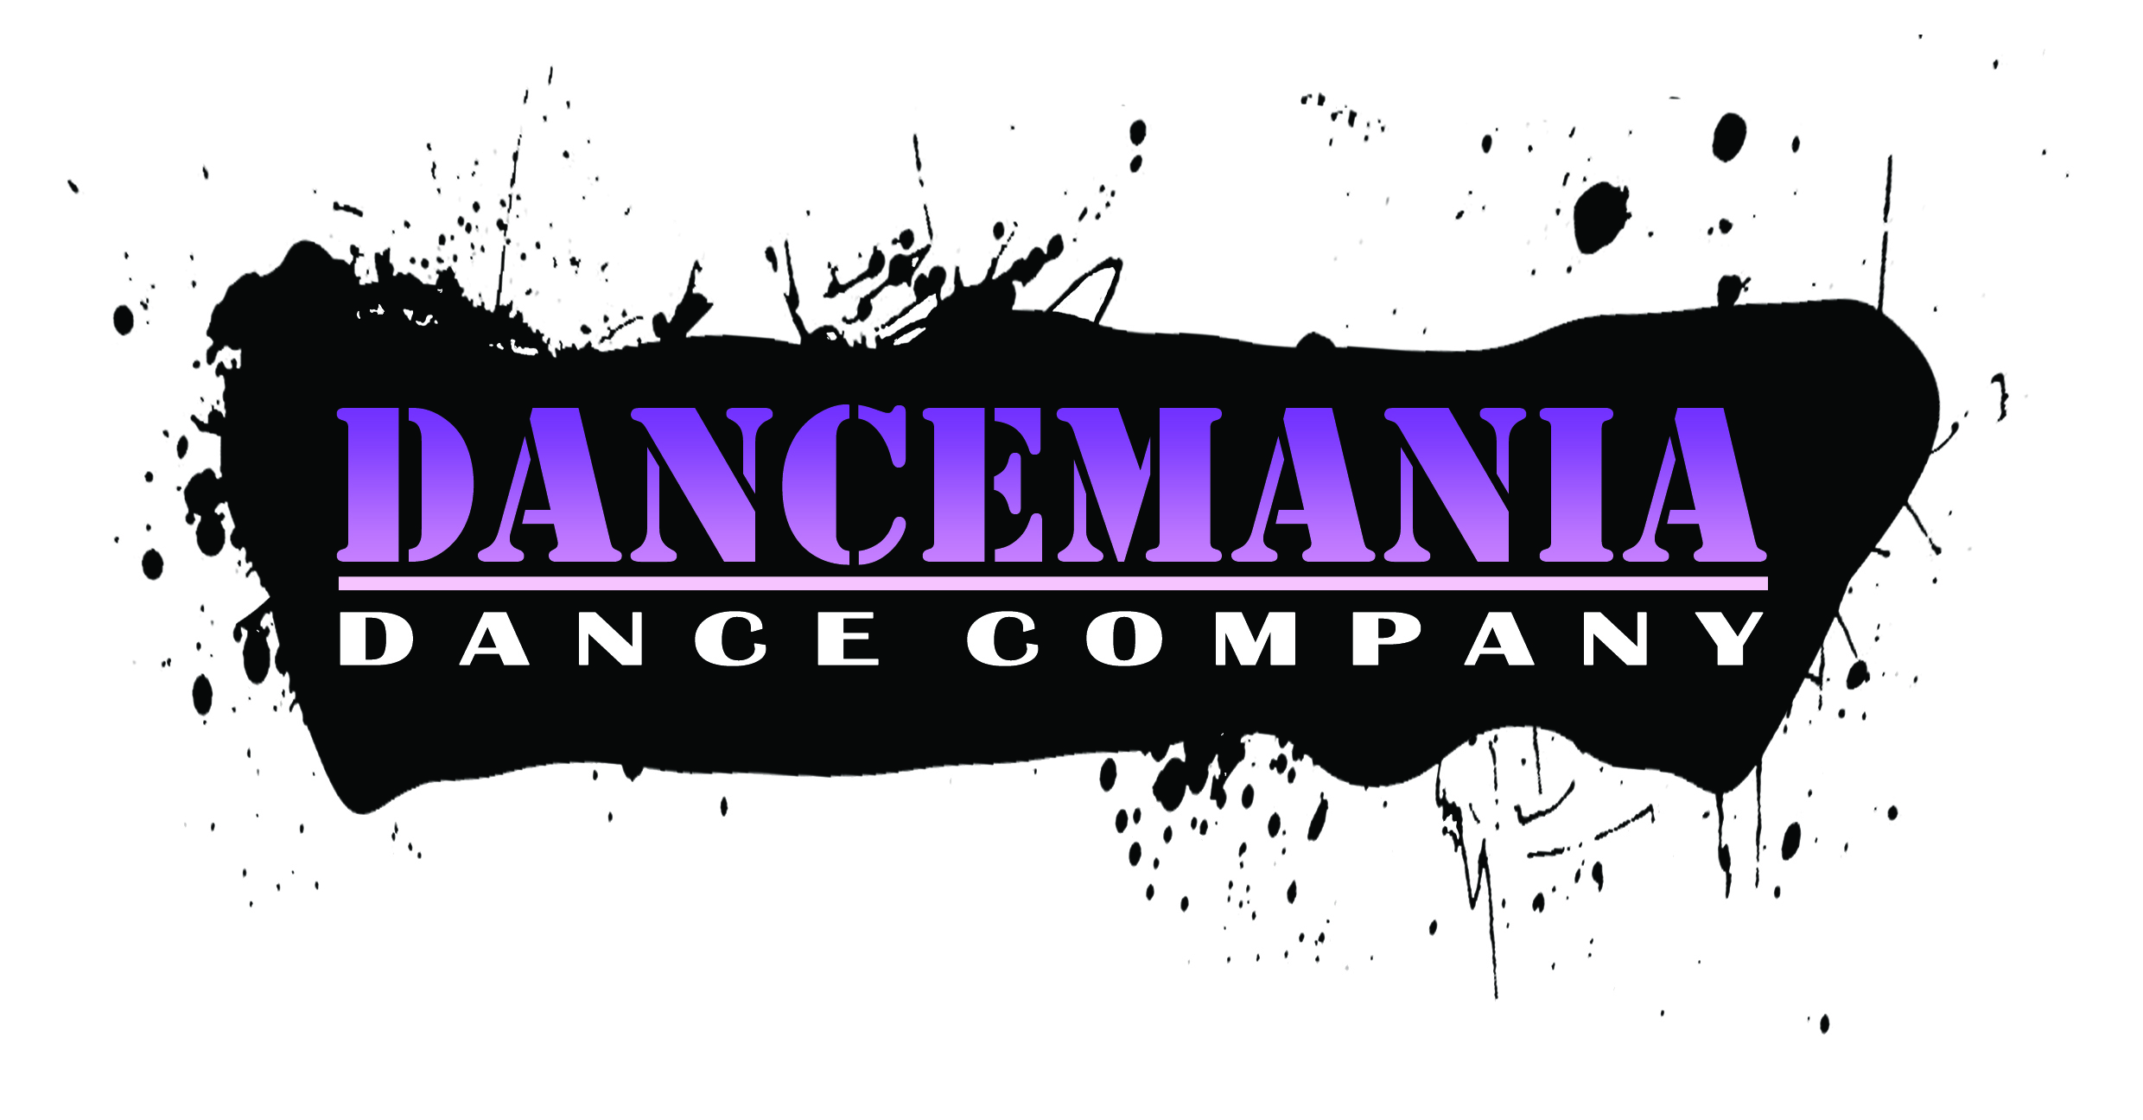CORONAVIRUS (Covid -19) Policy

Here are our protective measures in place as per guided from the most recent Government Guidelines.

- Separate Entrance and Exits to our Halls, to ensure classes to not cross.
- Please queue at the entrance or exit with a social distance of 2 metres. Parents to wear masks where possible.
- Parents/Guardians or other members of family dropping or picking up will not be allowed into the building. There will be no end of term invites to watch work for the time being, however, video footage can be sent across of your child’s work to see how they are progressing. Parents/Guardians not to wait on the premises unless sat in their own car. Parents not to gather with other parents to chat.
- All students upon entering and exit to hand sanitise. To encourage correct hand washing of 20 seconds before arrival or after a toilet break.
- Please wear a pair of outdoor shoes to your dance class, these can be taken off at entrance and carried to their designated spot at edge of dance floor whereby they can change into relevant dance shoes, trainers. Please sanitise dance shoes before class and after using anti-bacterial wipes. (We will have wipes on us too) This will cut down on cleaning floors as often and keeping the floor safe and not wet for falls etc.
- Coats and any other items not needed in class to be given to parents/Guardians. Upon entering the session, a teacher/student helper will guide them to spot marks around edge of room for placement of drink bottles and any relevant dance shoes. And then to their designated dance spot.
- Students encouraged to bring their own tissues and hand sanitiser. To encourage students to cough into tissues or elbow and use of correct bins within the halls.
- If feeling unwell please keep your child away from class. If a child becomes unwell in class, we will isolate the student from the main class and contact parent/Guardian to collect.
- Dance teachers, student helpers will wear face shields for meet and greet, but will be unsafe to wear whilst teaching. Once the students are at their designated spots, teachers will teach with social distancing in place. There will be no contact or use of hands to correct a student’s technique, however, other skills will be used to ensure correct/safe teaching of technique is carried out.
- Our classes will work with social distancing in place. Children under 5 years, there may be need of some contact i.e. shoe lace tying, hands will be sanitised between each child and face shields worn.
- All contact work will be avoided during this time but replaced with lots of smiles and kindness to each other.
- If first aid is required full PPE will be worn (Face shield, mask, gloves apron) and parent/Guardian contacted.
- There will be no more than 15 students in a class with many working at lower numbers.
- Parents/Guardians to arrive 10 mins before class and 10 mins before pick up time. Due to the strict protocol of running these classes we cannot have children mixing with other classes, or waiting/hanging around the building. Should you arrive more than 5 minutes late we ask that you miss the class that week. Any late pickups will incur extra costs of £5 for every 5 minutes a parent/Guardian is late. It is imperative our teachers are keeping the students safe and time is allowed for cleaning between classes, therefore we cannot use staff for looking after children should a parent be late in picking up.
- Dance halls will be sanitised/cleaned before and after a class. Any barres, surfaces, door handles, will be cleaned with anti-bacterial spray/Wipes. Floors will be regularly cleaned with anti-bacterial floor wipes. Where possible doors will be kept open along with windows to encourage good air ventilation, and avoid unnecessary contact with door handles etc.
- All uniform to be washed after each class, and a good idea to give dance shoes a wipe with anti-bacterial floor wipes after each class.
- Students taking holidays, we ask that you follow the quarantine guidance and that you do not return to dance before the appropriate quarantine period has been satisfied.
- We are not making any extra charges for Sanitisation or PPE, however for the next half term, classes will finish 5minutes earlier to allow time for cleaning and to allow one class to leave and time to greet the new class.
- Please cater for rainy days, a good idea to keep rain coats and umbrellas in the car.
- We will keep all contact details of staff and students for the Test and Trace system. Should a Student/teacher test positive the NHS will be notified who may ask for all contact details of anyone they have been in contact with.
- We will have a no touch infrared thermometer and may take students temperature on arrival. If a student has a temperature of over 37.8 degrees Celsius or above the student will not be permitted to enter the class.
- Toilet runs, no assistance can be given, taps and door handles will be sanitised. Students under 5 years, help will be given if needed but shields, gloves worn. Students under the age of 4 years, parents will be asked to stay with their child and be treated as one heartbeat.
- If a parent as any concern with any of the above procedures we ask that you do not return to class until you are happy.
- And lastly, please do get in touch should you need any further guidance or concerns

